**2010_CCES_data Codebook**

“age”: age in years

“agesq”: age in years, squared

“male”: dichotomous indicator where 1=male, 0=female

“unemp”: dichotomous indicator where 1=unemployed and 0=employed

“black”: 1=black, 0=not black

“hisp”: 1=Hispanic, 0=not Hispanic

“educ2-educ6”: dummy variables representing highest level of education with “less than high

school degree as the excluded category,” corresponding with HS degree, some college, 2-year degree, 4-year degree, and post-graduate degree.

“income”: 14 category variable representing increasing levels of household income

“union”: 1=family member in union, 0=no union membership

“pid”: standard, 7-point U.S. partisanship scale, with values 1=strong Democrat, 2=weak D,

3=lean D, 4=independent, 5=lean Republican, 6=weak R, 7=strong R

“south”: 1=live in southern region of U.S., 0=live elsewhere

“follow”: 4-category variable ranging from 0 to 3, with higher values indicating greater interest

in following politics and public affairs

“inctax”: ranges from 0-100, derived from the following question:

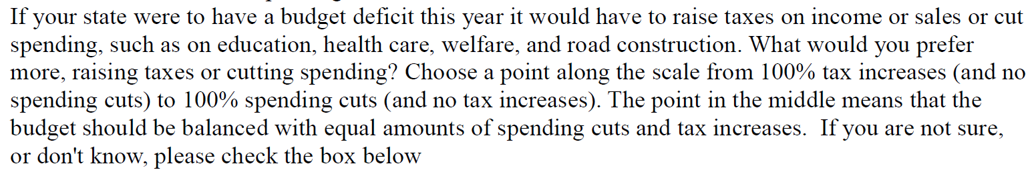

This variable is coded so that 100=all tax increases and 0=all spending cuts.